 **NIMS COLLEGE**

Registration No : 6-2-756-8-2019

(Tribhuvan University)

*Kanibahal, Lalitpur*

Lab Report

of

Cloud Computing

Submitted by Submitted To

Raj Kumar Karki Department of Humanities & Social Science

Semester: 7th  BCA (Bachelor in Computer Application)

….………………………

External Examiner

# Table of Contents

|  |  |  |
| --- | --- | --- |
| **S.N** | **Topic** | **Signature** |
| 1. | Create a shared folder in Google Drive and invite a teammate to collaborate |  |
| 2. | Create a new Google Docs document |  |
| 3. | Create a new Google Sheets spreadsheet and enter sample data |  |
| 4. | Design a presentation on Google Slides with at least five slides |  |
| 5. | Create a survey using Google Forms |  |
| 6. | Explore the learn Sandbox |  |
| 7. | Create an Azure resource |  |
| 8. | Repository Creation on GitHub |  |
| 9. | Create an virtual machine in Azure |  |
| 10. | Create network access in Azure |  |

**Google Drive**

1. Create a shared folder in Google Drive and invite a teammate to collaborate. Share a document within the folder and demonstrate simultaneous editing by both users.

**Theory:**

Google Drive is a cloud-based storage service that enables users to store and access files online. The service syncs stored documents, photos and more across all the user's devices, including mobile devices, tablets and PCs.

Google Drive integrates with the company's other services and systems including [Google Docs](https://www.techtarget.com/whatis/definition/Google-Docs), Gmail, Android, [Chrome](https://www.techtarget.com/whatis/definition/Google-Chrome-OS), YouTube, [Google Analytics](https://www.techtarget.com/searchbusinessanalytics/definition/Google-Analytics) and [Google+](https://www.techtarget.com/whatis/definition/Google-plus). Google Drive competes with Microsoft OneDrive, Apple iCloud, Box, Dropbox and SugarSync.

**Screenshot:**

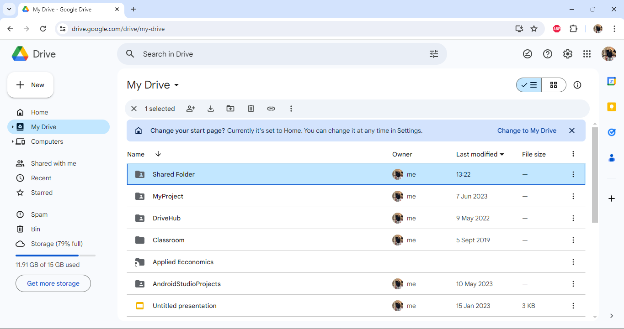

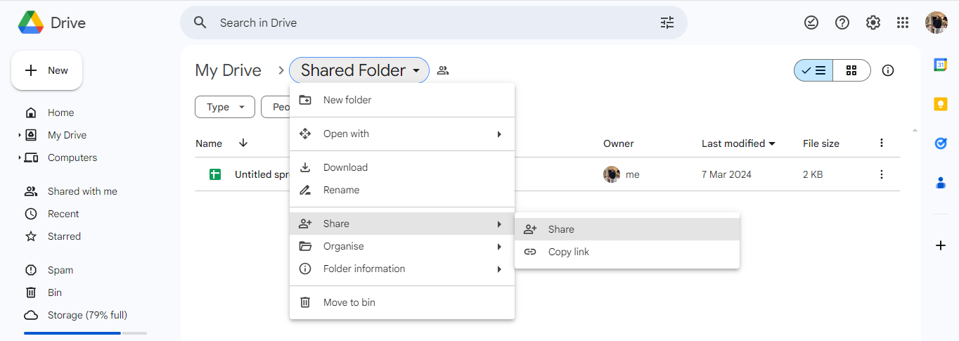

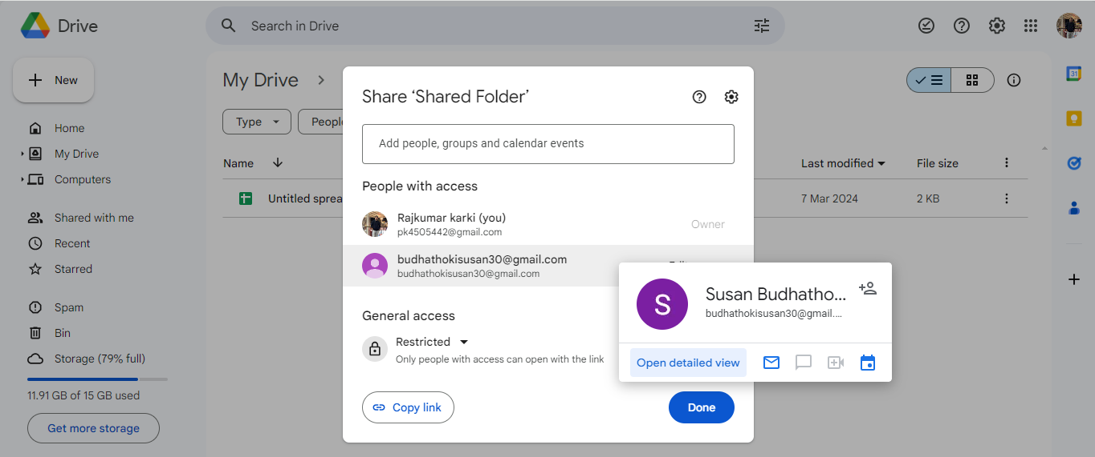

**Figure: Google Drive**

**Google Docs**

1. Create a new Google Docs document and format it with headings, bullet points, and numbered lists. Share the document with a colleague and collaborate on writing a short report.

**Theory:**

Google Docs is a free web-based [word processor](https://www.techtarget.com/searchwindowsserver/definition/word-processor) in which [documents](https://www.techtarget.com/whatis/definition/document) can be created, edited and stored as part of the Google Docs Editors suite of free web applications. Google Docs users can import, create, edit and update online documents in various [fonts](https://www.techtarget.com/whatis/definition/font) and file formats that can be accessed from any computer with an internet connection and [web browser](https://www.techtarget.com/whatis/definition/browser).

**Screenshot:** 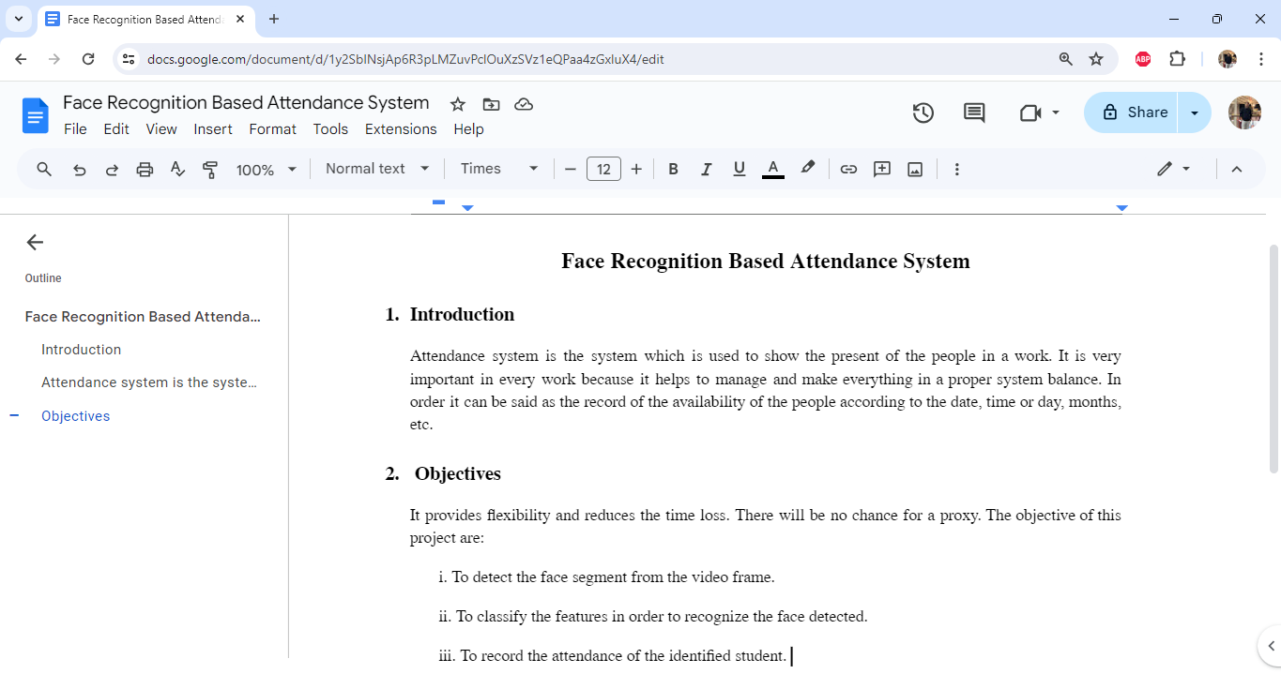

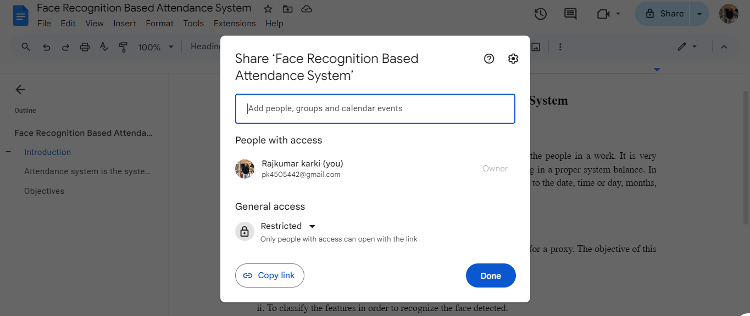

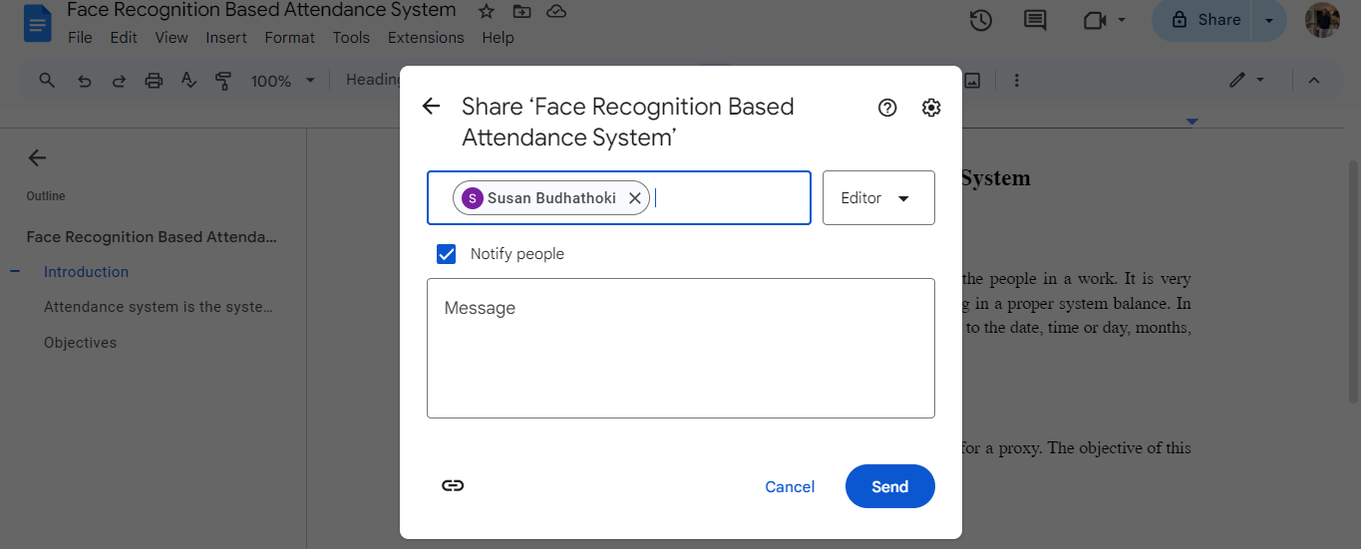

**Figure: Google Docs**

**Google Sheets**

1. Create a new Google Sheets spreadsheet and enter sample data. Use formulas to perform basic calculations such as sum, average, and count. Share the spreadsheet with another user and allow them to edit.

**Theory:**

Google Sheets is a free, web-based spreadsheet application that is provided by Google within the Google Drive service. The application is also available as a desktop application on ChromeOS, and as a mobile app on Android, Windows, iOS, and BlackBerry. It allows users to edit, organize, and analyze different types of information. It allows collaborations, and multiple users can edit and format files in real-time, and any changes made to the spreadsheet can be tracked by a revision history.

**Screenshot:**

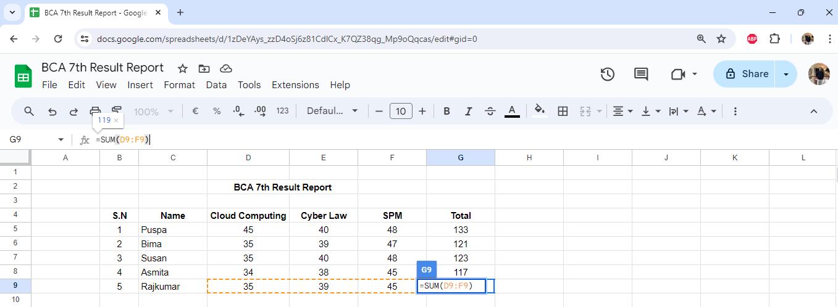

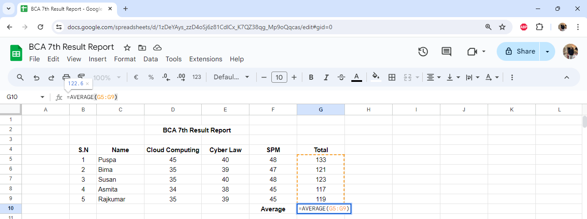

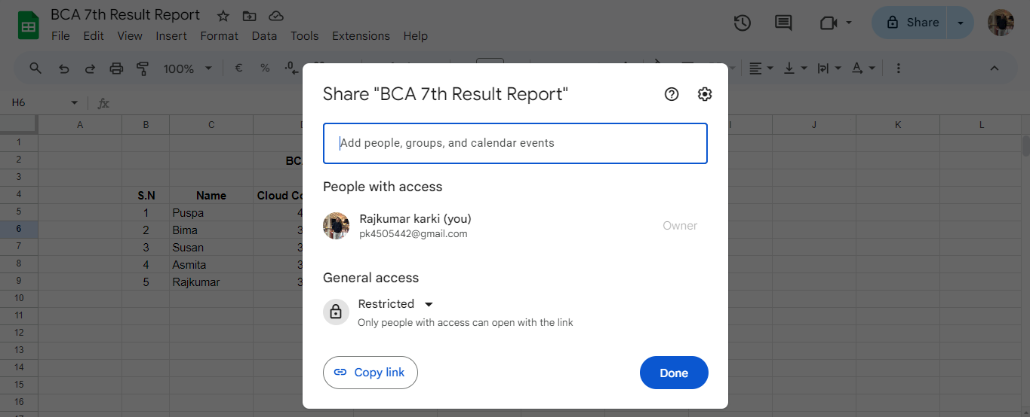

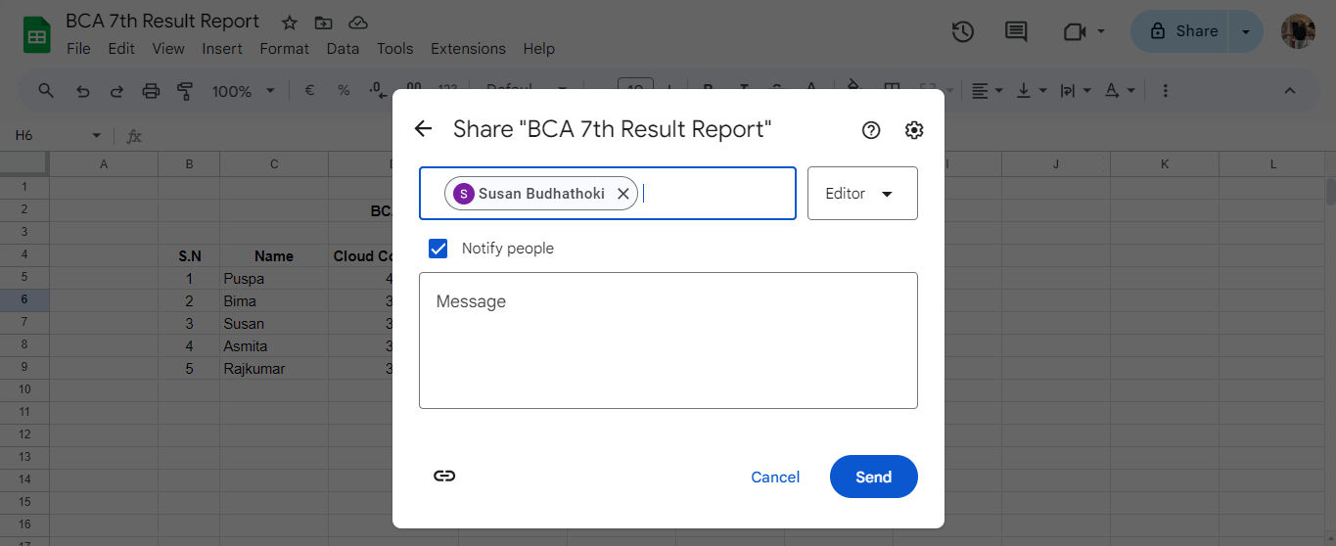

**Figure: Google Sheets**

**Google Slide**

1. Design a presentation on Google Slides with at least five slides. Include images, text, and transitions. Share the presentation with a peer for feedback and make revisions based on their suggestions.

**Theory:**

A Google Slides presentation has the same purpose as a PowerPoint presentation which serve as visual support in an oral presentation. However, Google Slides offers different advantages such as being able to have your presentation in the Google cloud and have access to it from anywhere and from any device, that several users can modify the same presentation at the same time or that all changes are automatically saved thanks to the auto-save feature.

**Screenshot:**

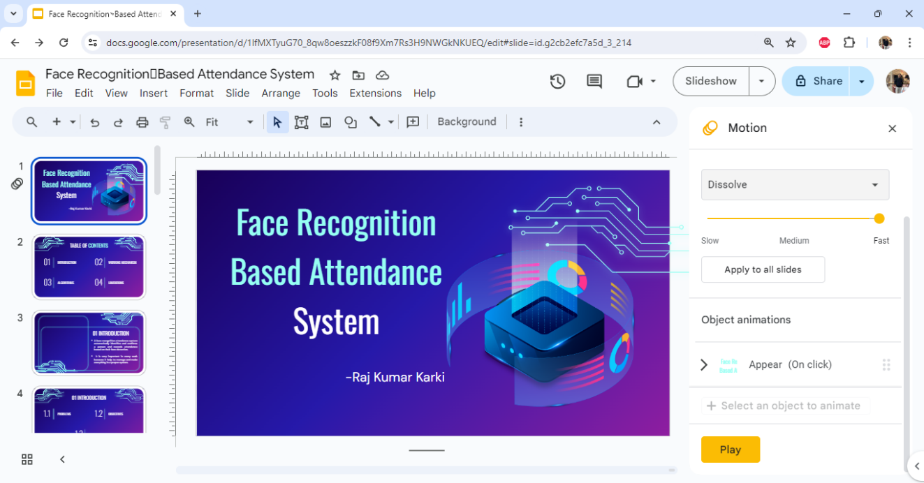

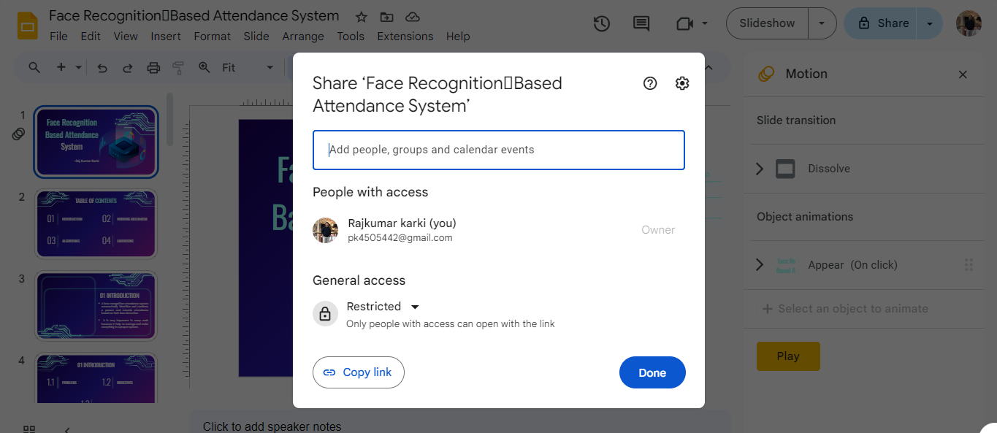

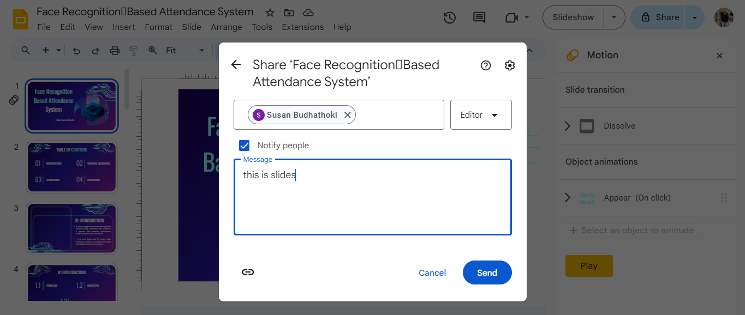

**Figure: Google Slide**

**Google Forms**

1. Create a survey using Google Forms with various question types such as multiple choice, short answer, and checkbox. Share the form link with classmates and collect responses.

**Theory:**

[Google Forms](https://www.google.com/forms/about/" \t "https://edtechbooks.org/onlinetools/_self) is a free online tool from Google which allows users to create forms, surveys, and quizzes as well as to collaboratively edit and share the forms with other people. Educators can use Google forms to assess their students at the beginning of the class  and gauge pre-existing knowledge. Furthermore, Google forms can be used to give feedback to and receive feedback from students and parents. Similarly, students can use Google forms to assess their own learning and set the learning goals as well as to collect data for their research projects*.*

**Screenshot:**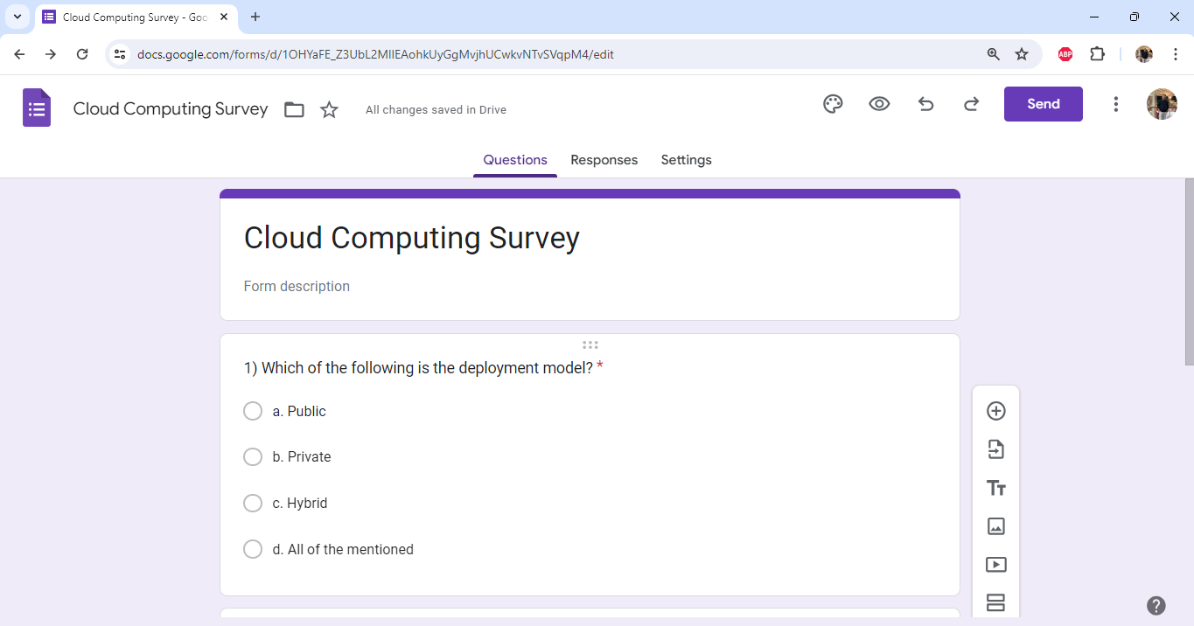

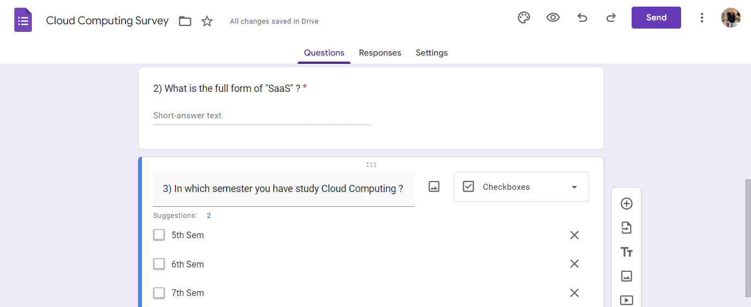

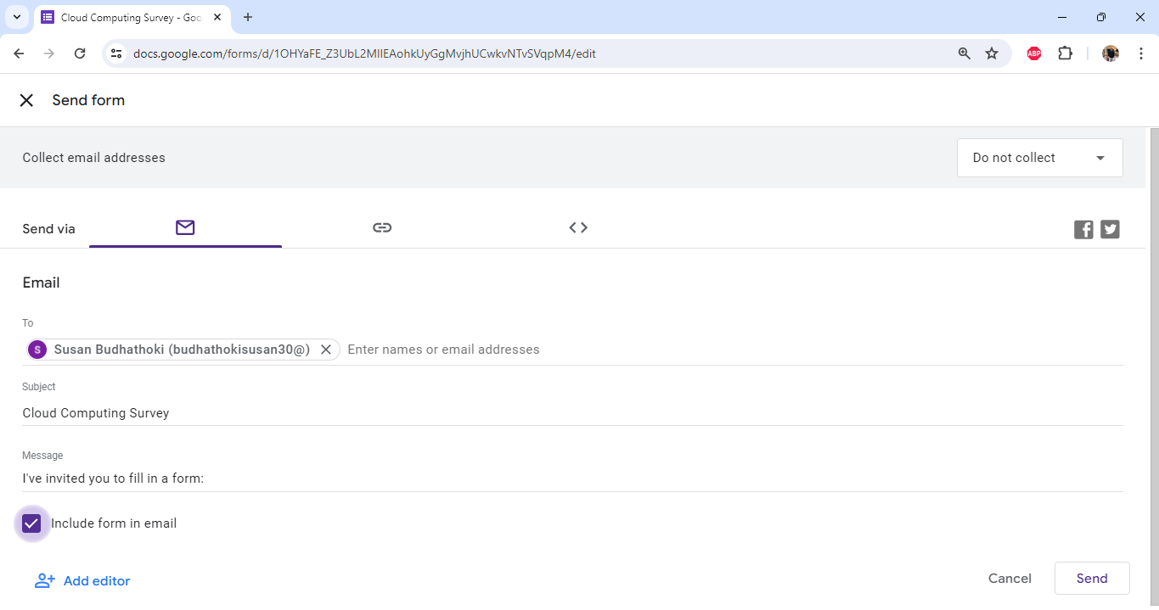 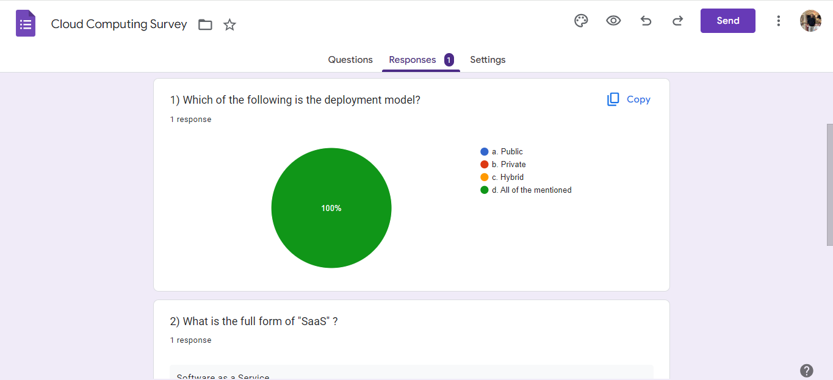

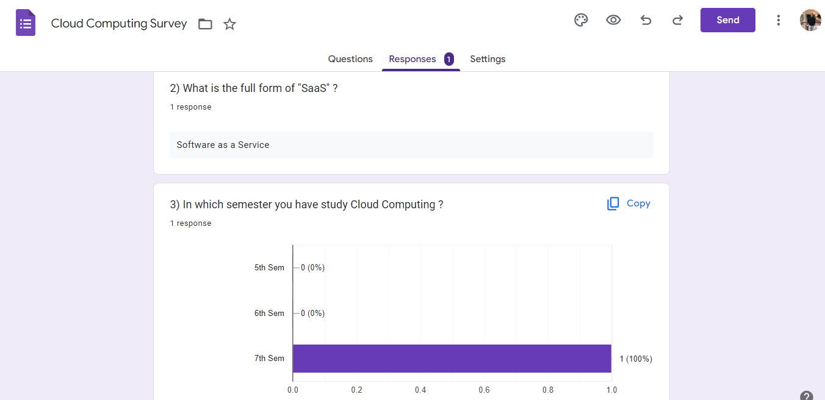

**Figure: Google Forms**

**SandBox**

1. Explore the learn Sandbox.

**Theory:**

Sandboxing is a security practice in which you use an isolated environment, or a “sandbox,” for testing. Within the sandbox you run code, analyze the code in a safe, isolated environment without affecting the application, system or platform.

**Screenshot:**

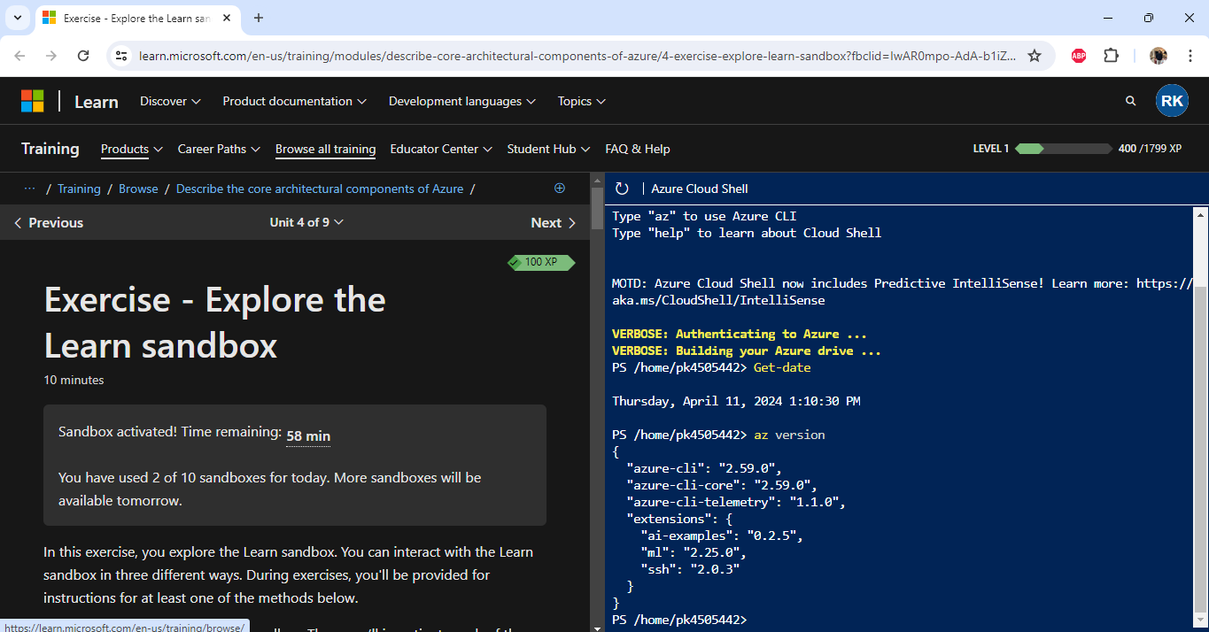

**Figure: Sandbox**

**Azure**

1. Create an Azure resource.

**Theory:**

Azure Resource Manager is the deployment and management service for Azure. It provides a management layer that enables you to create, update, and delete resources in your Azure account. You use management features, like access control, locks, and tags, to secure and organize your resources after deployment.

**Screenshot:**

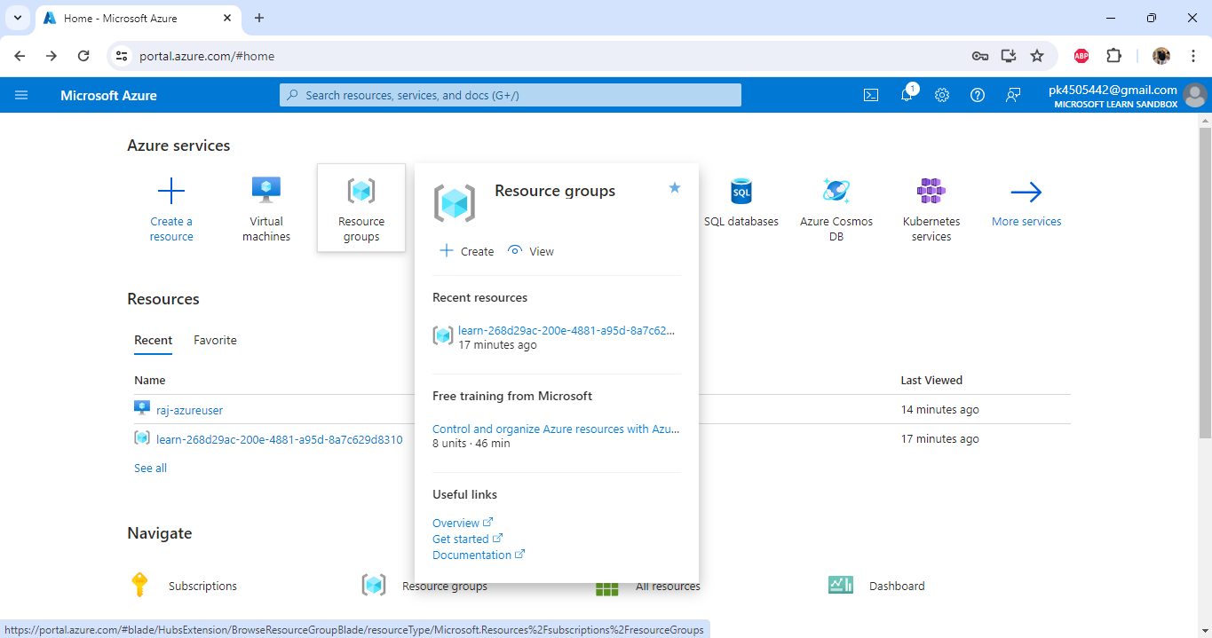

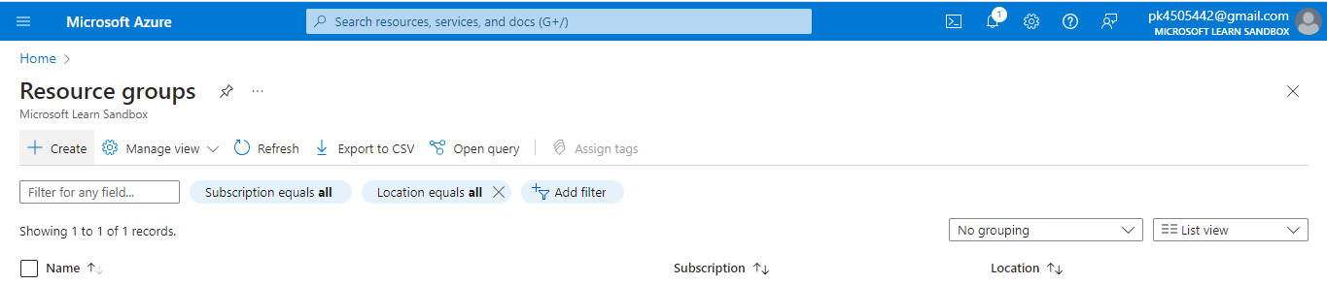

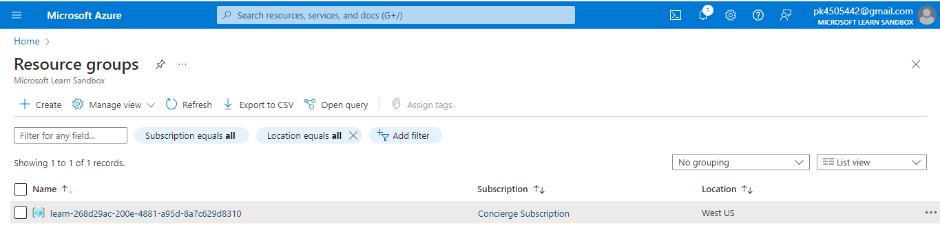

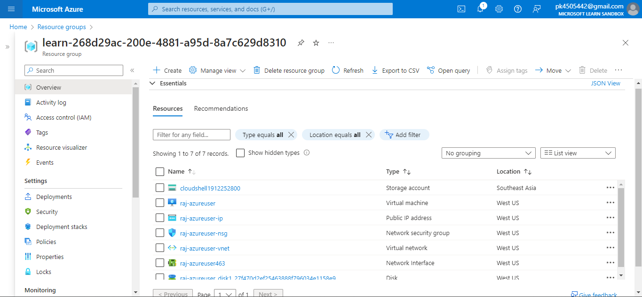

**Figure: Azure resource**

**GitHub**

1. Create a new repository on GitHub with a descriptive name related to a school project or hobby. Write a brief description explaining the purpose of the repository. Add a simple README file with instructions or information about the project.

**Theory:**

[GitHub](https://github.com/) is a web-based interface that uses [Git](https://git-scm.com/), the open source version control software that lets multiple people make separate changes to web pages at the same time. As Carpenter notes, because it allows for real-time collaboration, GitHub encourages teams to work together to build and edit their site content.

GitHub allows multiple developers to work on a single project at the same time, reduces the risk of duplicative or conflicting work, and can help decrease production time.

**Screenshot:**

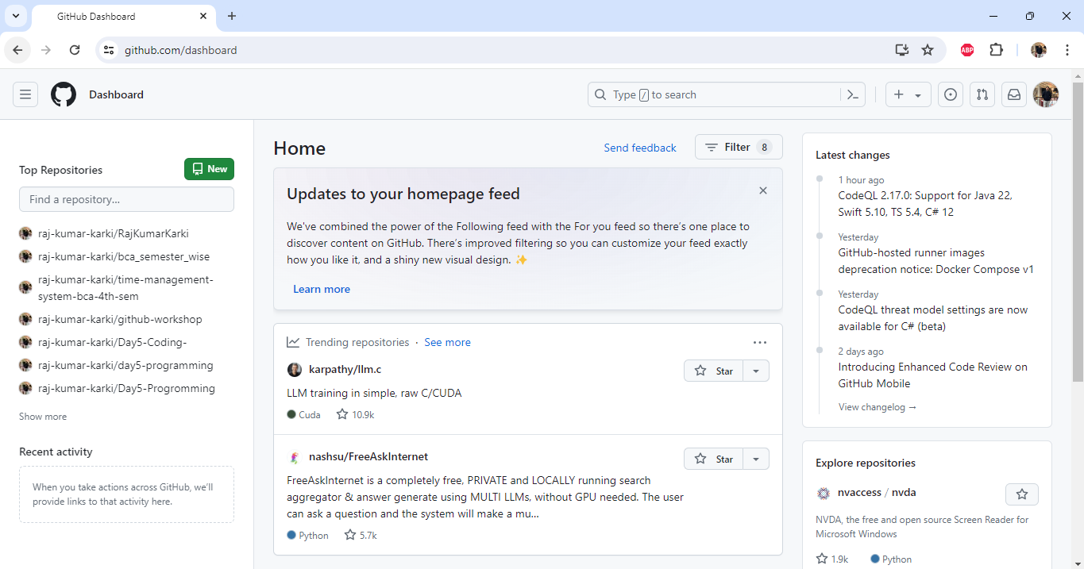

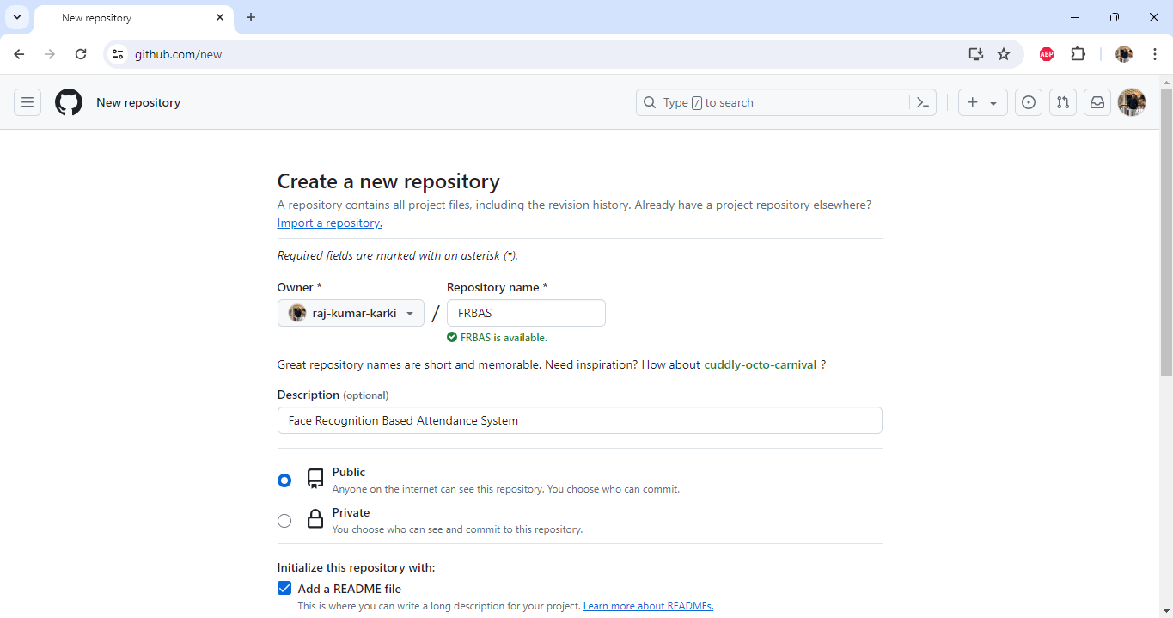

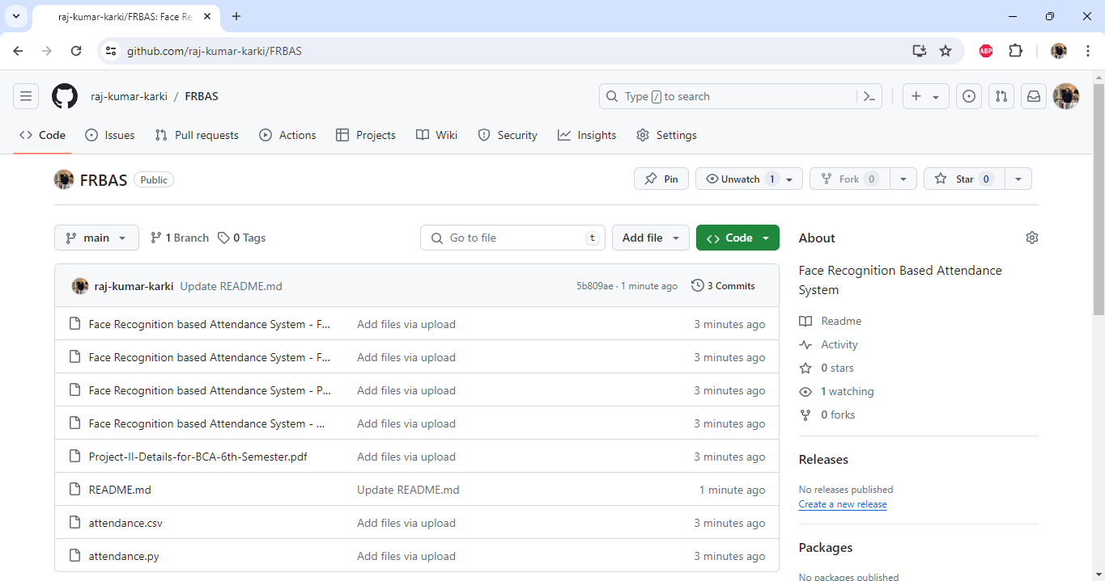

**Figure: GitHub**

**Virtual Machine**

1. Create an virtual machine in Azure.

**Theory:**

A virtual machine is like a physical computer but it is actually a digital version of it. Actually, it is not so much different from physical computers because they have also [memory](https://www.geeksforgeeks.org/computer-memory/), [CPU](https://www.geeksforgeeks.org/central-processing-unit-cpu/), as well as they have disks to store our data or various files and one more interesting thing is that they can also connect to the internet. So we can say that a VM is actually the software-defined computer that exists only as a code but is present on [physical servers](https://www.geeksforgeeks.org/servers-in-computer-network/).

**Screenshot:**

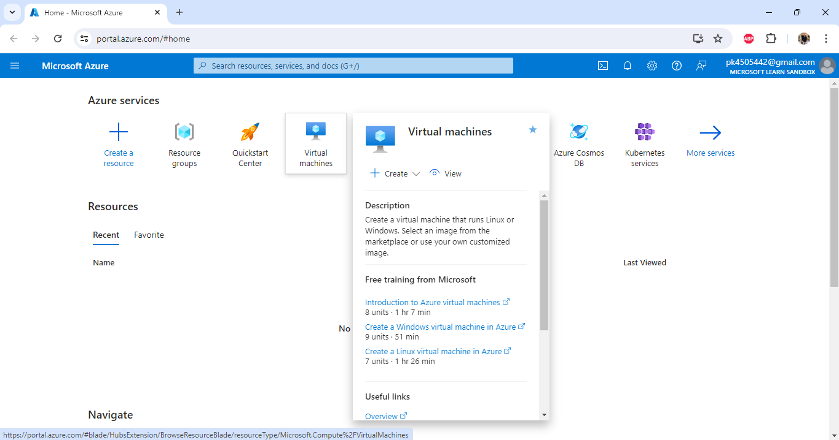

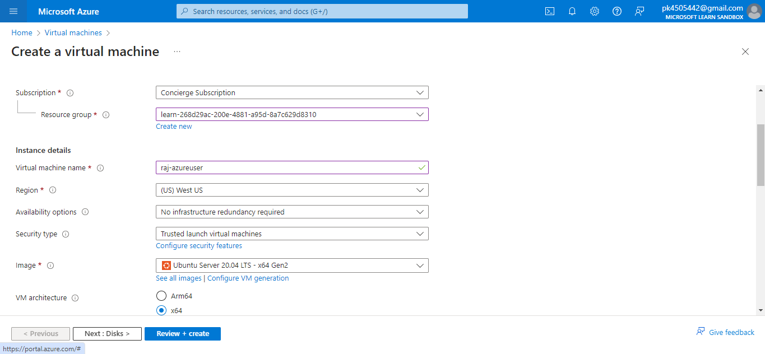

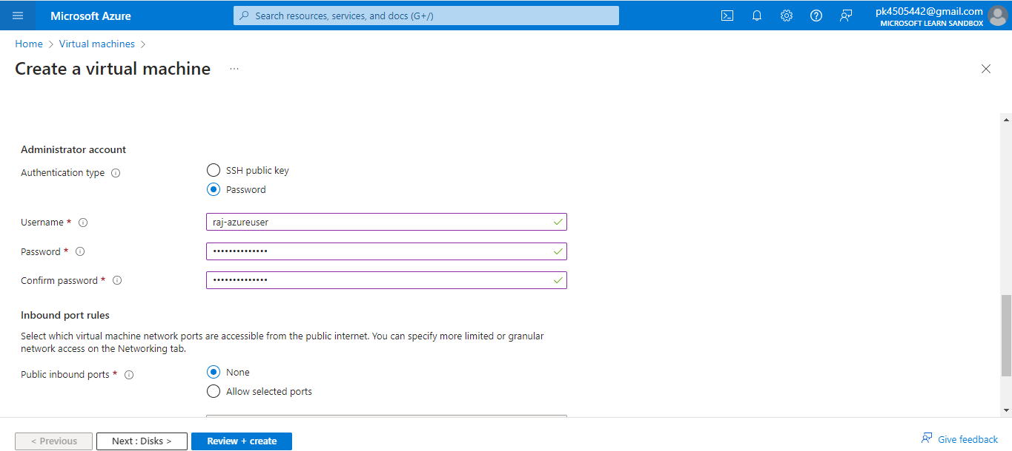

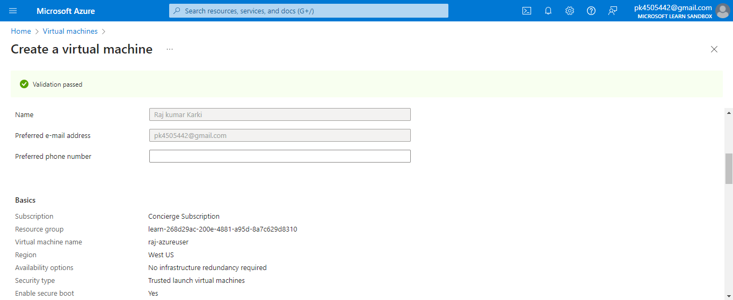

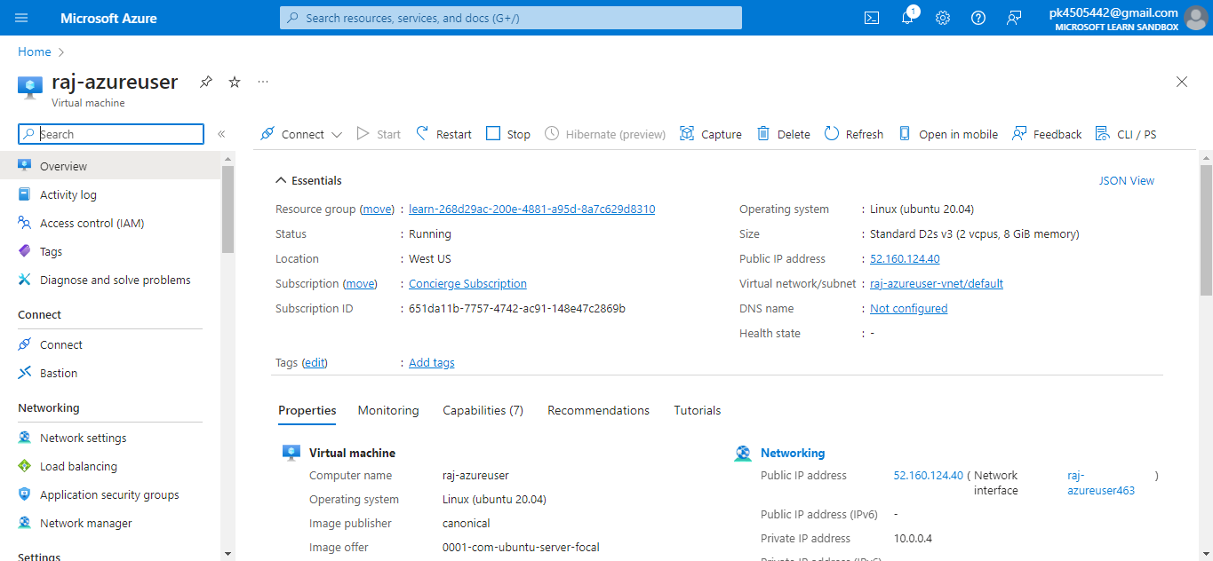

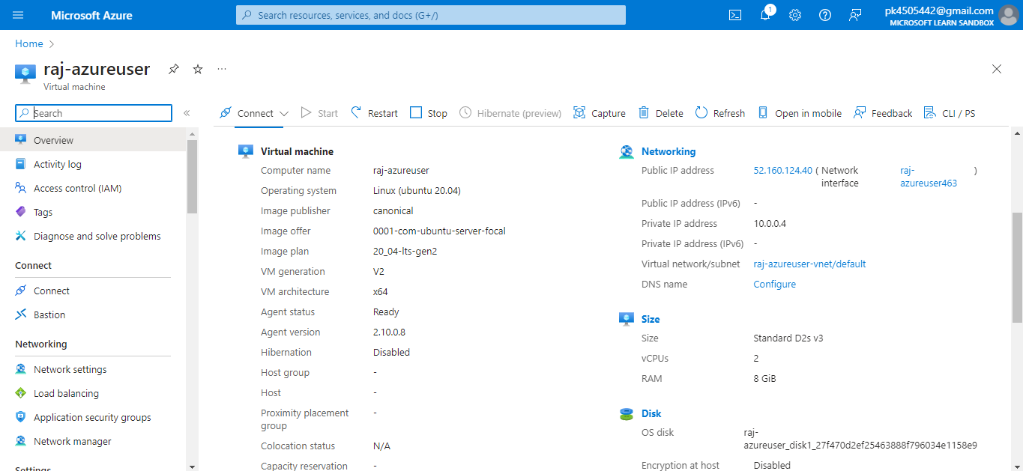

**Figure: Azure Virtual Machine**

**Network Access**

1. Create network access in Azure.

**Theory:**

Network access is a crucial layer of cyber security which is an important pillar in securing resources. This is true even when other security controls to protect resources are in use, such as user name/password combination, connection strings or security tokens. Malicious actors find network restricted access difficult to get around.

**Screenshot:**

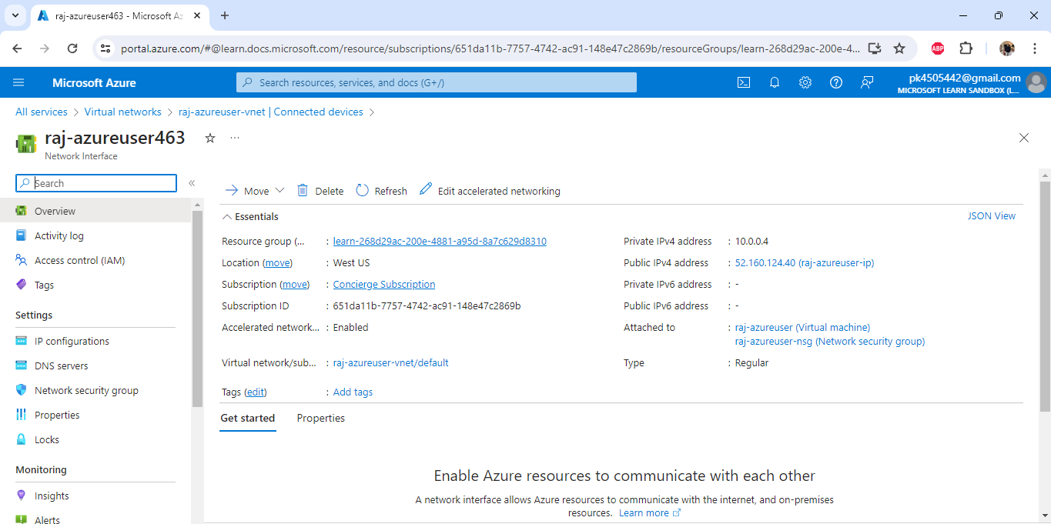

**Figure: Network Access in Azure**